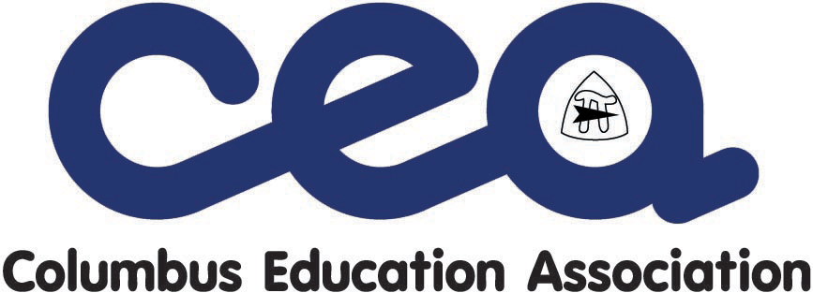
Health and Safety

The 2019-2022 CEA Master Agreement includes new contract language regarding the occupational health and safety of CEA members. Faculty Representatives play a key role in enforcing this language and ensuring members are utilizing the newly negotiated procedures for addressing such concerns.

New and Revised Contract Language

206.05 The parties agree that consistent with board appropriations, building budgets and the district facilities plan(s), all school buildings should be provided with adequate resources and equipment in a safe infrastructure, with reasonable attention to lighting and snow and ice removal in school parking lots. The board shall make reasonable efforts, taking into account timing, transportation, cost and other relevant considerations, to address lack of power, heat or water in a building in a manner that is safe and promotes the well being of students and teachers. Complaints about alleged non-compliance with EPA or OSHA regulations are subject to the following process, notwithstanding the provisions of R.C. 4167.10 (b)(1) regarding the existence of imminent danger:
a. An employee or association representative shall file in writing a health and safety complaint with the immediate supervisor or principal within five (5) work days of the occurrence of the alleged violation.
b. If the immediate supervisor or principal does not respond in writing to the alleged violation to the satisfaction of the employee/association with ten (10) work days, the employee or the association may appeal the complaint to the director of buildings and grounds by filing a written appeal with the director within five (5) work days of the immediate supervisor/principal’s response or due date to respond. The director or designee shall respond in writing to the compliant within ten (10) work days of submission of the appeal. If the corrective action is identified in the response, then the response shall include a planned date of project completion.
c. After receiving the response from the director of buildings and grounds, a bargaining unit member who is dissatisfied with the disposition of the health and safety compliant may file a compliant with the Ohio Bureau of Workers Compensation Public Employees Risk Reduction Program (PERRP) using form SH-6.

206.16 Health and Safety Committee

The board and the association shall establish a labor-management health and safety committee. The committee shall be composed of four (4) representatives appointed by the board and four (4) representatives appointed by the association. The duties of the committee will be to identify health and safety related problems, evaluate current and recommend, as appropriate, new health and safety work practices and procedures, improve communication about the work order process, and promote awareness and encourage compliance with health and safety practices and procedures. The committee shall meet quarterly. A designee of the committee shall report at least annually to the joint labor-management committee pursuant to section 108.02.

Health and Safety

Health and Safety Complaint Process Overview
Step | Who | Action | Deadline | Notes
One | Bargaining unit member and/or CEA Faculty Representative | File health and safety complaint in writing with immediate supervisor or principal | Within five workdays of the occurrence and/or violation | The new joint Health and Safety Committee will determine a mutually agreed-upon form for such complaints. In the meantime please submit via email to principal/supervisor and cc: CEA at: CEAHealthSafety@ceaohio.org.
 | Principal or immediate supervisor | Responds in writing | Within ten work days of complaint filing | If complainant(s) are satisfied with response, process ends. If not satisfied or no response received, move to step two.
Two | Bargaining unit member and/or CEA Faculty Representative | Appeal health and safety complaint in writing to Director of Buildings and Grounds | Within five work days of the immediate supervisor/principal’s response or due date to respond | The new joint Health and Safety Committee will determine a mutually agreed-upon method for such appeals. In the meantime please submit via email to Director of Buildings and Grounds DeJuan Hood at dhood@columbus.k12.oh.us and cc: CEA at: CEAHealthSafety@ceaohio.org.
 | Director of Buildings and Grounds | Responds in writing | Within ten work days of appeal filing | If corrective action is identified in the response, then the response must include a planned date of project completion. If complainant(s) are satisfied with response, process ends. If not satisfied or no response received, move to step three.
Three | Bargaining unit member and/or CEA Faculty Representative | File complaint with Ohio Bureau of Workers Compensation Public Employees Risk Reduction Program (PERRP) using form SH-6. | N/A | PERRP form SH-6 can be found at: https://www.bwc.ohio.gov/downloads/blankpdf/SH-6.pdf. This fillable pdf can be submitted via email to perrpcomplaint@bwc.state.oh.us. When filing, cc: CEA at: CEAHealthSafety@ceaohio.org.

What Happens Once a Complaint is Filed with PERRP?
PERRP will notify the employer in writing of the complaint (not including the name of the complainant). The employer must investigate, correct and respond to the allegations within 30 days. If the employer does not respond, or if PERRP determines the response is inadequate, an inspection of the workplace will result. Two outcomes can result from a complaint inspection.
- PERRP determines there are no reasonable grounds to believe that a violation or danger exists. If this occurs, the complainant will be notified of the outcome.
- PERRP identifies violations and issues citations to the employer that require corrective action. If the employer fails to correct identified hazards within the allotted time, they may face fines.

