Go to www.scholastic.com/bookclubs
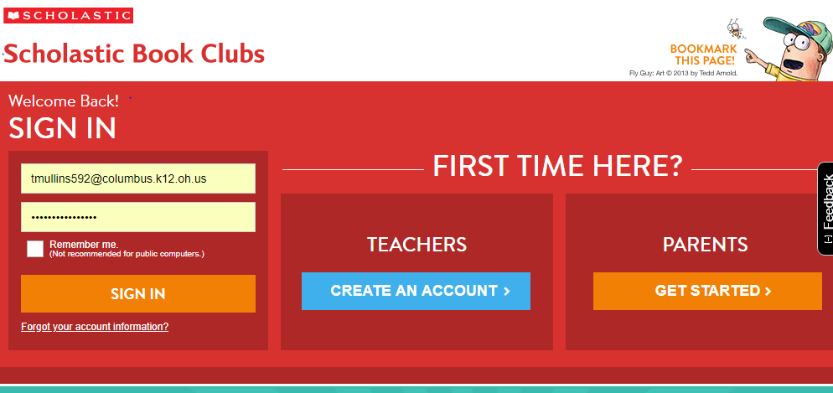
Click on parents

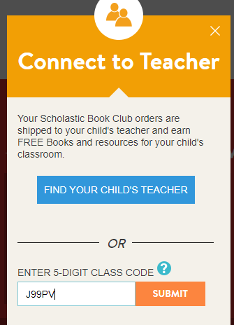

Enter the class code “J99PV”, hit submit
You will have to create an account, may do it prior to ordering, or once ordered.
This will allow you to pay via credit card and will be mailed to the office.
If you order three (3) or more books online make sure you write Scholastic Book order on your gift card drawing slip

